NAME :JAYAHARINI.J

REG NO:192371034

1. Create an HTML page that displays the following:

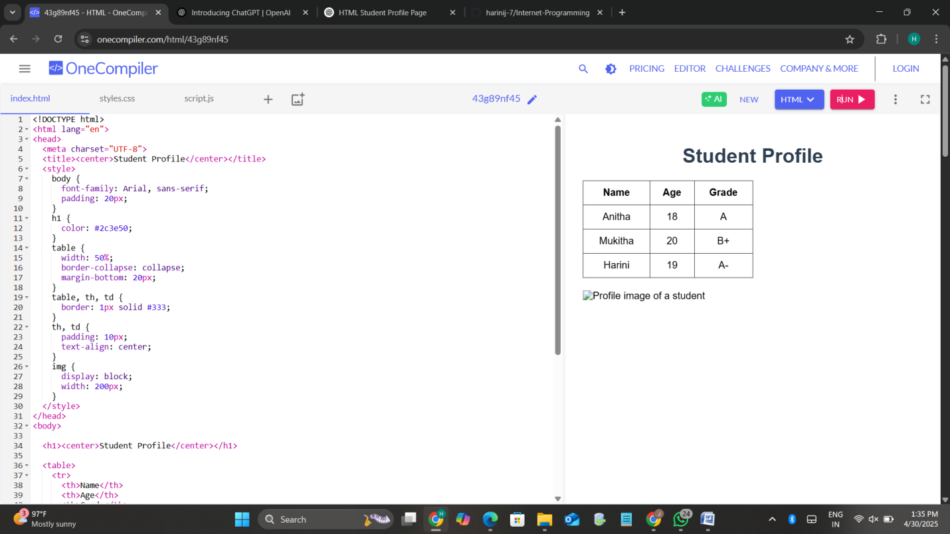

2. Embed Audio and Video with HTML5 Controls

